W-16
YEAR 12 PHYSICS
ASSIGNMENT 6 - LIGHT & ATOMIC PHYSICS
Name: Mark: 

1. 2015 Q 11

Question 11 (7 marks)
The first five energy levels (not to scale) of a hydrogen atom are shown in the figure below.

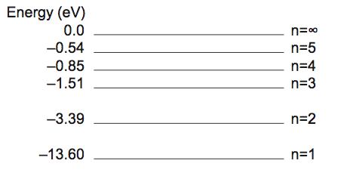
(a) Calculate the highest and lowest frequency photons that an excited electron in the n = 5 level within a hydrogen atom can emit. Show all workings. (4 marks)

Highest: Hz Lowest: Hz

(b) In the diagram below, indicate the possible pathways by which an electron at energy level n = 3 can return to ground state. (3 marks)

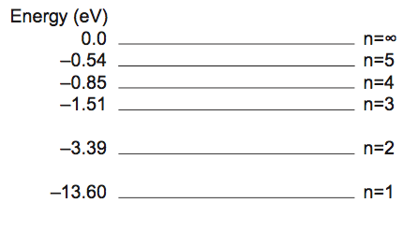
2. 2014 Q2

Question 2
Electromagnetic radiation (emr) is said to have both wave and particle properties. State and describe an example of each of these properties of emr. (4 marks)

3. 2014 Q6

The images below show hydrogen spectra.

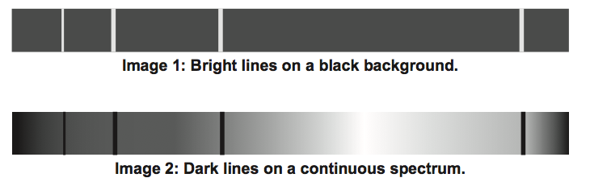

For each, name the type of spectrum and describe how it is created. (4 marks)

Image 1 spectrum type:

Created:

Image 2 spectrum type:

Created:

4. 2014 Q18

A hydrogen atom, in an excited energy level, undergoes relaxation by emitting a photon. The energy values are given by 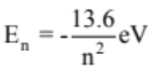. The initial state of the electron is in energy level n = 4 and the final state after relaxation is ground state (n = 1).

(a) Does the average radius of the electron orbital remain the same, increase or decrease in value during this transition? Circle the correct answer. (1 mark)

remains the same increases decreases

(b) Use the formula to complete the energy level diagram below. The diagram is not drawn to scale. (2 marks)

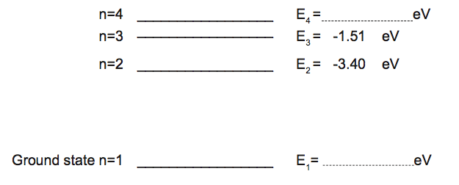

(c) On the diagram above, draw in all the possible transitions when an electron undergoes relaxation from n = 4 to the ground state. (3 marks)

(d) (i) Calculate the wavelength of the photon emitted from the E3 to E2 transition. Show all workings. (4 marks)

(ii) The transitions of E4 to E2 and E3 to E2 produce red and green photons. Explain which transition produces which colour. (3 marks)

5. 2013 Q7

The element helium gets its name from the Greek sun-god ‘Helios’. This is because helium is the only element to have been discovered in the Sun before it was isolated on the Earth. Helium was identified from unknown lines in the solar spectrum.

With reference to the discovery of helium, explain the origin and significance of lines in the solar spectrum. (4 marks)

6. Question 1 1999

Experimental work was carried out to investigate the photoelectric effect by shining light onto a particular metal surface. Measurements were made of the number and maximum kinetic energy of the emitted electrons from this particular metal surface for different frequencies and intensities of light.

(a) Which one of the following (A - D) was not one of the findings? (1 mark)
A. The ability to eject electrons from this metal depended only on the frequency of light.
B. At frequencies below the 'threshold frequency' no electrons were ejected from the metal no matter how high the intensity was.
C. The 'stopping potential' for the photoelectrons was independent of the light intensity.
D. The maximum kinetic energy of the photoelectrons depended only on the intensity of the light.

The apparatus shown below was set up to investigate the photoelectric effect.
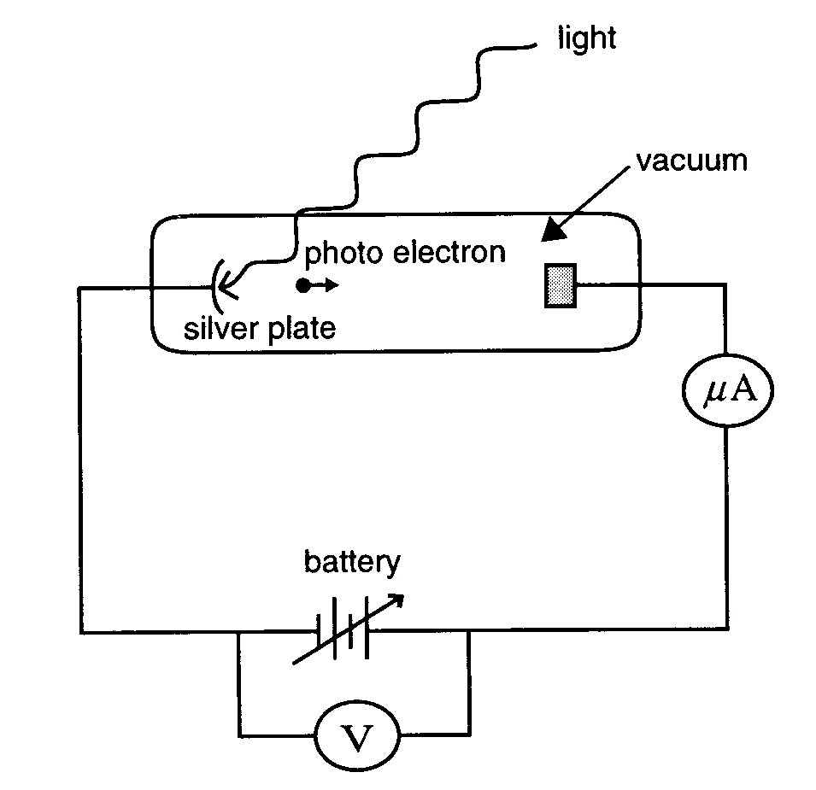

Using this apparatus, it is found that light of wavelength 254 nm (2.54 x 10⁻⁷ m) ejects photoelectrons from a silver plate. The work function of the silver surface is 7.52 x 10⁻¹⁹ J.

(b) Calculate the energy of a single photon of light of wavelength 254 nm (2.54 x 10⁻⁷ m).
(3 marks)

(c) What is the kinetic energy of the fastest moving photoelectrons ejected by light of 254 nm? (3 marks)

7. Question 2 1996

An experiment is carried out to investigate the photoelectric effect. Light of various single frequencies shines onto a clean metal plate inside an evacuated glass tube as shown below.
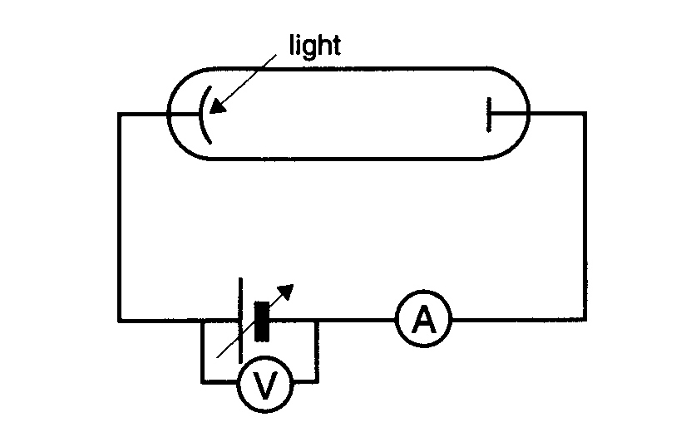

The maximum kinetic energy of the photoelectrons is measured for the different frequencies, giving the results shown below.
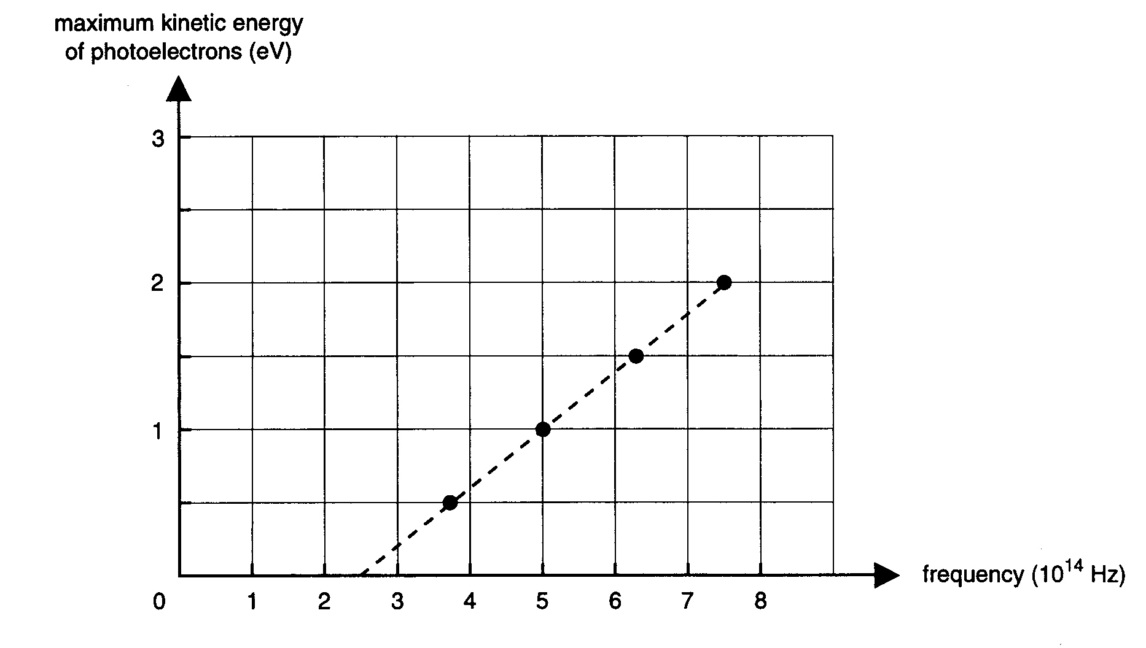
(a) From this graph calculate the value of Planck's constant, h, in the units eV s. You must show your working. (3 marks)

(b) Calculate the minimum retarding voltage needed to prevent an electron of kinetic energy 4.80 x 10⁻¹⁹ J from crossing the evacuated glass tube. (3 marks)

(c) Which one of the plotted lines (A - E) in the graph below would be obtained for the same metal plate for light of double the intensity. (1 mark)
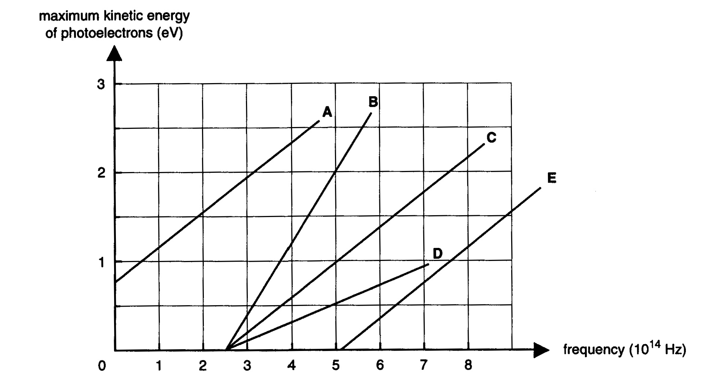

Newton proposed a particle model for light and Huygens proposed a wave model for light.

(d) Explain, giving reasons, how Einstein's interpretation of the photoelectric effect supported a wave or a particle model. (3 marks)

